Ideation Phase
Define the Problem Statements

Date | 18 Feb 2026
Team ID | LTVIP2026TMIDS71823
Project Name | Gemini Pro Financial Decoder: Transforming Complex Data into Actionable Insights
Maximum Marks | 4 Marks

Customer Problem Statement
Finance professionals such as financial analysts, business managers, investors, accountants, startup founders, and small–medium enterprise (SME) owners frequently work with large volumes of complex financial data including balance sheets, income statements, cash flow statements, market reports, and forecasts. Interpreting this data accurately is time- consuming, requires advanced financial expertise, and is prone to human error.
Many decision- makers struggle to extract clear insights from raw financial documents, especially when data is scattered across multiple sources or presented in technical language. This often leads to delayed decisions, missed opportunities, and increased financial risk. The primary goal of Gemini Pro Financial Decoder is to simplify, analyze, and translate complex financial data into clear, actionable insights using AI, enabling faster and more confident financial decision- making. The solution can be delivered through a web- based or mobile application where users can upload financial documents and receive intelligent summaries, risk indicators, trends, and recommendations.
Reference:https://miro.com/templates/customer-problem-statement/

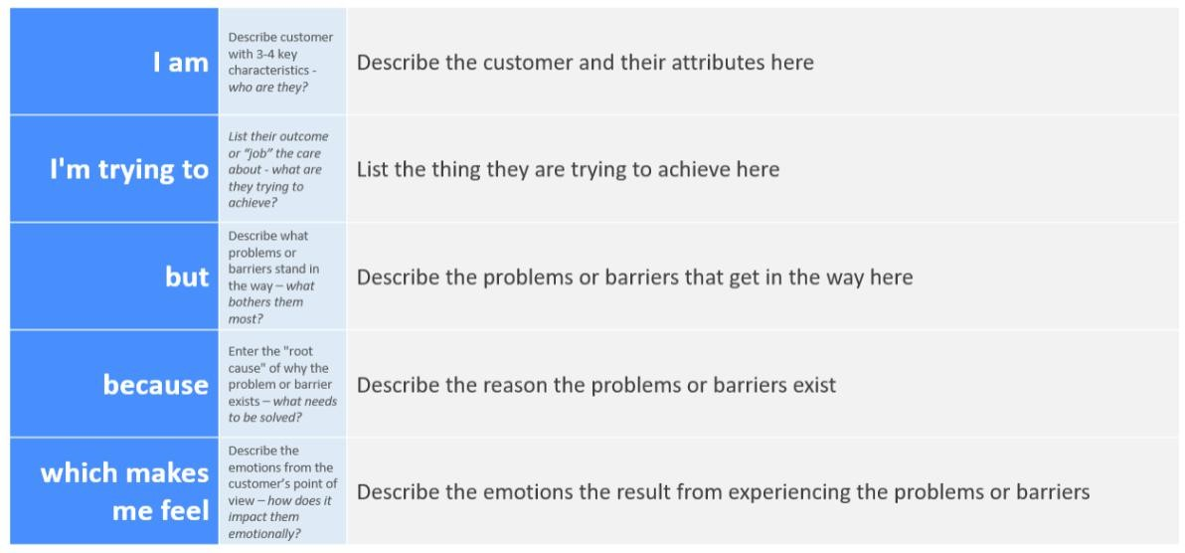

Problem Statement (PS) Template

Problem Statement | I am (Customer) | I’m trying to | But because | Which makes me feel
PS- 1 | Financial Analyst | analyze financial reports and identify key insights for decision- making | the data is complex, unstructured, and spread across multiple documents | I spend excessive time interpreting data instead of focusing on strategy, making me feel overloaded and inefficient
PS- 2 | Business Owner / Startup Founder | understand my company’s financial health and future risks | I lack deep financial expertise and reports are filled with technical jargon | I feel confused and uncertain about making critical business decisions
PS- 3 | Investor | evaluate companies quickly before making investment decisions | financial statements are lengthy and require detailed manual analysis | I feel anxious about missing red flags or profitable opportunities
PS- 4 | Accountant / Finance Manager | prepare accurate financial summaries and forecasts | manual analysis is time- consuming and prone to calculation or interpretation errors | I feel stressed and pressured to deliver error- free reports on time
PS- 5 | Non- Finance Professional | interpret financial data shared by my organization | I don’t have tools that explain financial numbers in simple language | I feel disconnected and hesitant to contribute to financial discussions

